**PROBAR FUNCIONAMIENTO APACHE**

mkdir /home/david /htdocs  
nano /home/david/htdocs/index.php

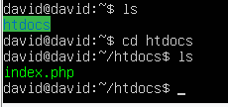   
  
  
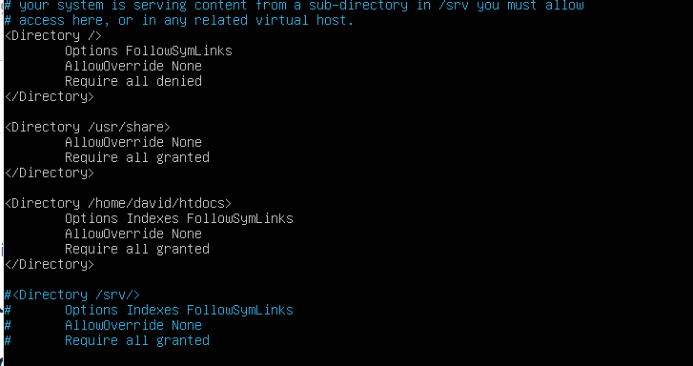  
sudo service apache2 reload

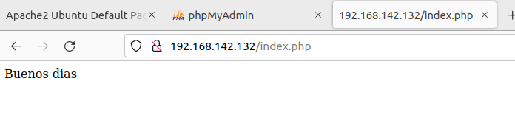

Webgrafia: Stackoverflow